**Design Credit (EEN1010)**

**Project: MATLAB Analysis of Time-Modulated FSS system**

**Introduction**

In the project, "MATLAB Analysis of Time-Modulated FSS system,"we propose a new method for frequency-shifting the reflection of electromagnetic waves using a time-modulated active tunable frequency-selective surface (FSS). The FSS is composed of a periodic array of metal patches that are individually addressable. The software named ADS is used to generate a dataset of S-parameters, magnitude of reflection coefficient, and phase of reflection coefficient for the FSS. Then we use MATLAB/Python to write code that uses the dataset to generate graphs of the reflected signal and spectrum. The graphs show that the time-modulated FSS is able to suppress the original incident frequency component and boost the sideband frequency components.

The work presented in this paper is a significant contribution to the field of electromagnetics. The proposed method for frequency-shifting the reflection of electromagnetic waves using a time-modulated active tunable FSS could have a variety of applications, such as radar, communication, and imaging. The authors have shown that the time-modulated FSS is able to achieve a high degree of frequency-shifting, and they have also shown that the performance of the FSS is insensitive to the amplitude and phase of the incident wave. This work provides a promising new approach for frequency-shifting electromagnetic waves.

The presented research paper introduces a technique for modulating electromagnetic (EM) waves using actively tuned frequency-selective surfaces (FSSs) to shift the frequency of the reflected waves. The modulation is achieved by applying a time-varying periodic biasing voltage across varactor diodes in the FSS, which changes the reflection coefficient and modulates the reflected EM wave. The modulated wave contains significant components at multiple sideband frequencies along with the original incident frequency, allowing for the suppression of the incident frequency component and the boosting of the sidebands.

The proposed technique has potential applications in evading Doppler radar systems, where the velocity of an object is detected from the Doppler shifted frequency of the received signal. By modulating the reflected EM wave, the presence of multiple frequency sidebands and the suppression of the original frequency component can make Doppler radar imaging difficult or even impossible when the modulation frequencies are dynamically managed.

The paper describes the design of a time-modulated active tunable FSS, which consists of a 2D array of unit cells with varactor diodes. The capacitance of the varactor diodes can be tuned by changing the biasing voltage, resulting in a modulated reflection coefficient and a modulated reflected EM wave. The modulation performance of the designed modulator surface is verified experimentally using a fabricated prototype.

Two modulation schemes, sinusoidal and saw-tooth biasing, are demonstrated in the paper to show symmetrical and asymmetrical power distributions in the sidebands. The results show that the incident frequency component can be effectively suppressed while boosting the sideband frequencies.

The paper concludes by discussing the limitations of the presented modulator and the potential applications of the frequency-shifted reflection technique in evading Doppler radar and other radar imaging systems.

**Geometry of the Tunable Frequency Selective Surface(FSS)**

The tunable active Frequency-Selective Surface (FSS) is composed of a 2-D array of unit cells. Each unit cell consists of two metallic triangular arms connected through a varactor diode. The varactor diode used is the SMV 1249-079LF with dimensions of 1.2 × 0.7 mm². The arms of adjacent unit cells are connected through biasing lines.

The FSS is printed on an FR4 dielectric substrate with a thickness of 1.6 mm. An air spacer with a thickness of 6 mm separates the substrate from the metal ground plane. The dimensions of the FSS elements are as follows: a = 25 mm, l = 23 mm, wb = 0.2 mm, w1 = 0.8 mm, and w2 = 0.57 mm.

The choice of a dipole structure with triangular arms is based on its simplicity and ease of connecting bias lines. This geometry allows for the tunability of the FSS by controlling the varactor diodes in each unit cell.

**DESIGN OF TIME-VARYING REFLECTION COEFFICIENT**

The proposed active tunable FSS is represented by an equivalent circuit model. The circuit model includes a series combination of components R1, L1, C1, and the varactor diode. The varactor diode is further modeled as a series combination of Rs (series resistance), Ls (series inductance), and the diode capacitance.

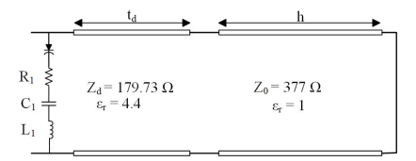

The air spacer and dielectric substrate are modeled as segments of a transmission line, representing their respective electrical properties. The ground plane is represented by a short circuit in the circuit model.

This equivalent circuit model allows for the analysis and simulation of the active tunable FSS's behavior and performance. By manipulating the values of the circuit components and the varactor diode, various characteristics of the FSS can be studied, such as frequency selectivity and tunability.

**Plotted the graphs using both matlab and Python .**

**(a)**

**(b)**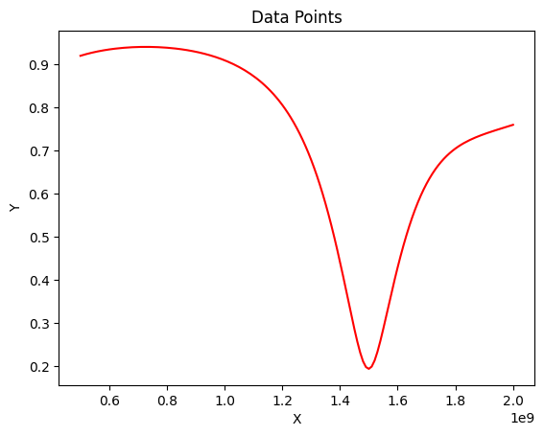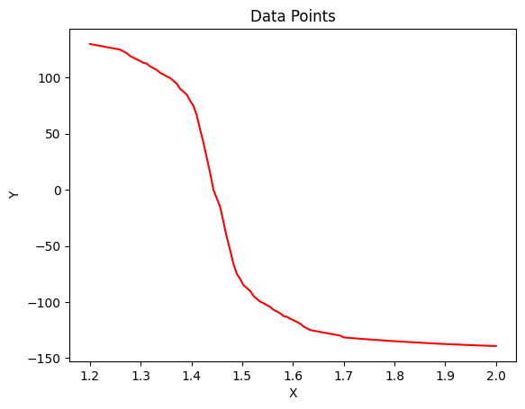

Equivalent circuit model of the tunable FSS for constant biasing voltage(a) Magnitude vs Frequency(GHZ). (b) Phase of the reflection coefficient vs Frequency(GHZ).

A. Sinusoidal Biasing Voltage

The bias voltage is given by Vb(t) = V**B** + vb sin(2π fbt), where VB = 2.6 V, vb = 1 V, and fb = 1 kHz. The diode capacitance varies between 12.08 and 4.44 pF due to the varying bias voltage.

It is observed that the time-varying reflection coefficient due to the applied sinusoidal biasing voltage does not vary outside the frequency range of 1.3–1.8 GHz. However, for an incident electromagnetic (EM) wave with a frequency inside the range 1.3–1.8 GHz, the reflection coefficient significantly varies.

Considering the incident frequency f**i** = 1.55 GHz, the diode capacitance for different instances can be obtained from Fig. 3 (not provided). The incident EM wave is assumed to be Ei(t) = sin(2π fi t).

The reflection coefficient depends on the diode capacitances, which are determined by the bias voltage at that particular instant. The electric field of the reflected signal can be calculated as Er(t) = |Γ(t)| sin[2π fi t + (∠Γ(t))], where Γ represents the reflection coefficient.

To obtain the values of fi(t) at different instances, you need to determine Vb(t) and simulate the tunable FSS design for the corresponding diode capacitance.

**(a)**

**(b)**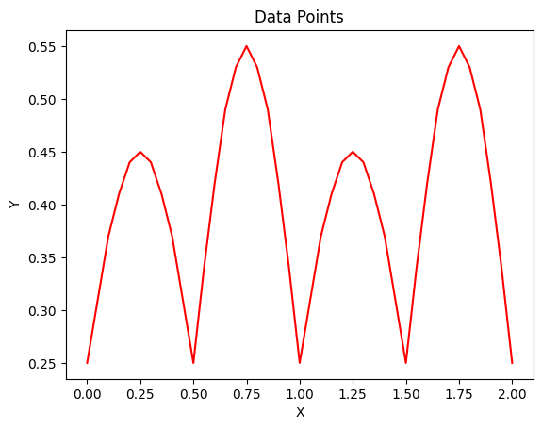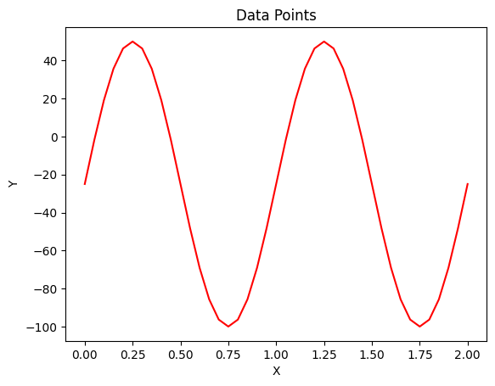

Reflection coefficient variation in time for applied sinusoidal

bias voltage. (a) Magnitude vs Time(ms). (b) Phase vs Time(ms)

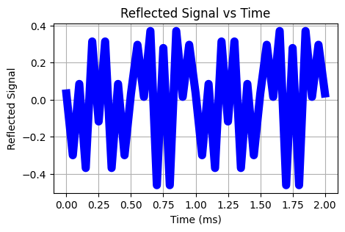

Reflected signal for applied sinusoidal biasing voltage. Signal in the

time domain in ms scale

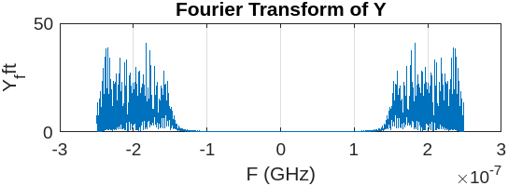

Frequency spectrum graph for Sinusodial Biasing Voltage

B. Saw-Tooth Biasing Voltage

The application of a saw-tooth biasing voltage to the varactor diode is depicted in Figure. The saw-tooth voltage has a frequency of 1 kHz and varies from 1.6 V to 3.6 V. It has a rise time of 90% and a fall time of 10%.

The time-varying reflection coefficient at 1.6 GHz is a consequence of the saw-tooth biasing voltage. This time-varying reflection coefficient leads to the modulation of an electromagnetic (EM) wave.



**(b)**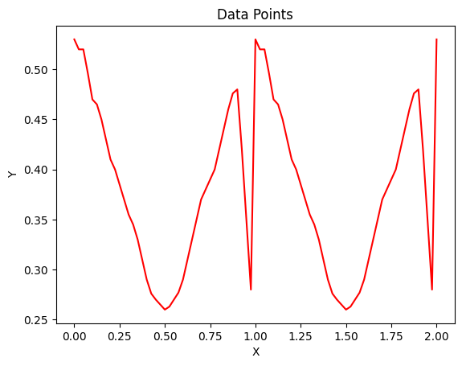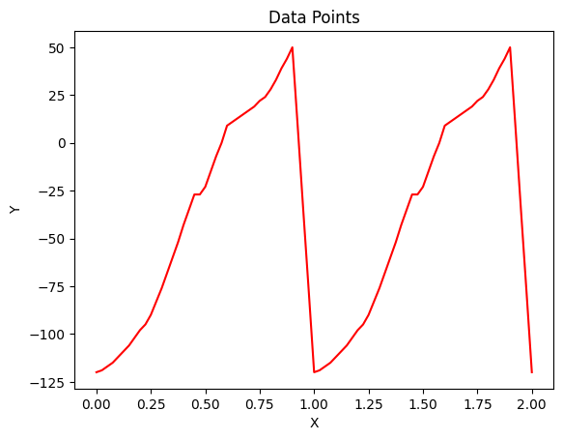

Variation in the reflection coefficient due to applied saw-tooth

biasing voltage. (a) Magnitude vs Time(ms), (b) Phase of the reflection coefficient vs Time(ms)

Frequency Spectrum  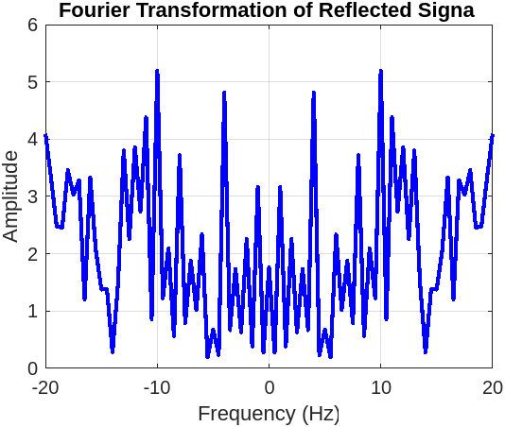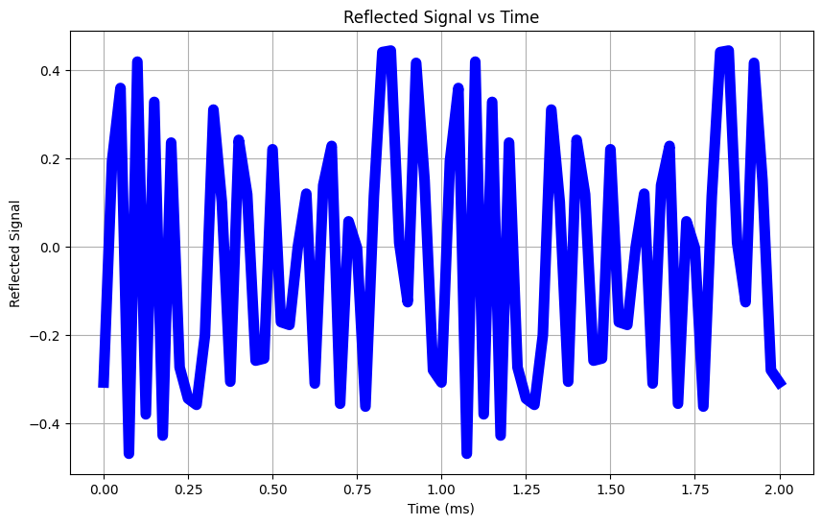

Reflected signal for applied saw-tooth biasing voltage. Signal in the

time domain in (a) ms scale

**CONCLUSION**

In this paper, we have presented a method for frequency-shifting the reflection of electromagnetic waves using a time-modulated active tunable frequency-selective surface (FSS). The proposed method is based on the use of varactor diodes to modulate the reflection coefficient of the FSS. By applying a time-varying bias voltage to the varactor diodes, the reflection coefficient of the FSS can be dynamically changed, which in turn causes the frequency of the reflected waves to be shifted.

The proposed method is a promising new technique for frequency-shifting the reflection of electromagnetic waves. It is relatively simple to implement and can be used to shift the frequency of the reflected waves over a wide range. The proposed method is also relatively efficient, as it does not require the use of any high-power amplifiers.  
  
The research presents a tunable FSS design that incorporates controlled varactor diodes and a periodic biasing voltage scheme to achieve a time-varying reflection coefficient. The results demonstrate effective suppression of incident frequency components, significant sideband boosting, and the potential for modulation of transmitted EM waves.